“The Great Shake Out” WCGARP Flew
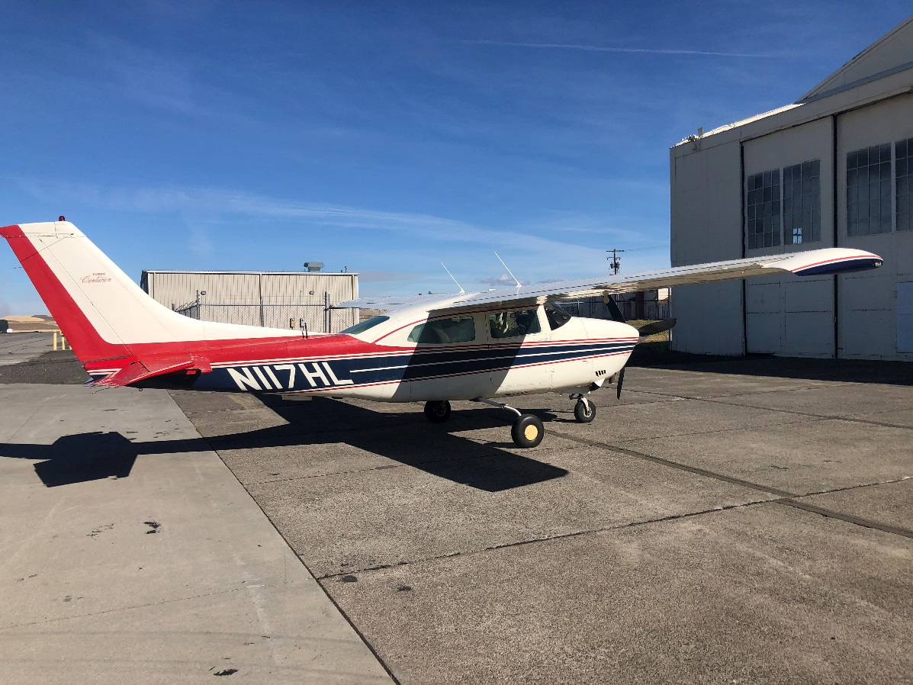
The WC EVAC DART plane arriving in Walla Walla to pick up the load.
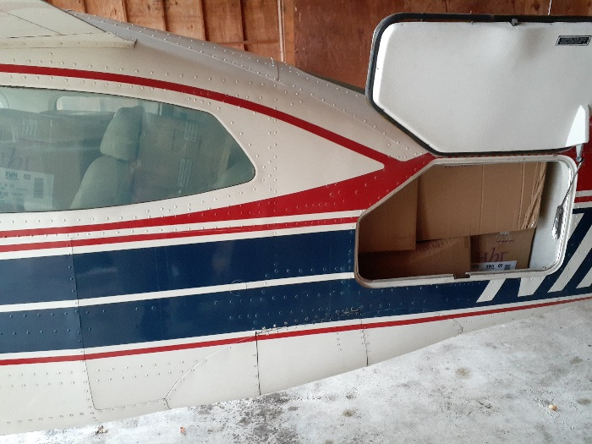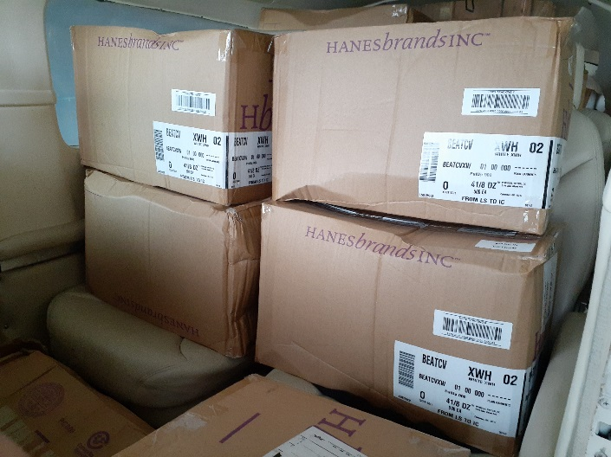
The WC EVAC DART plane arriving at Bellingham International Airport after having picked up the load.
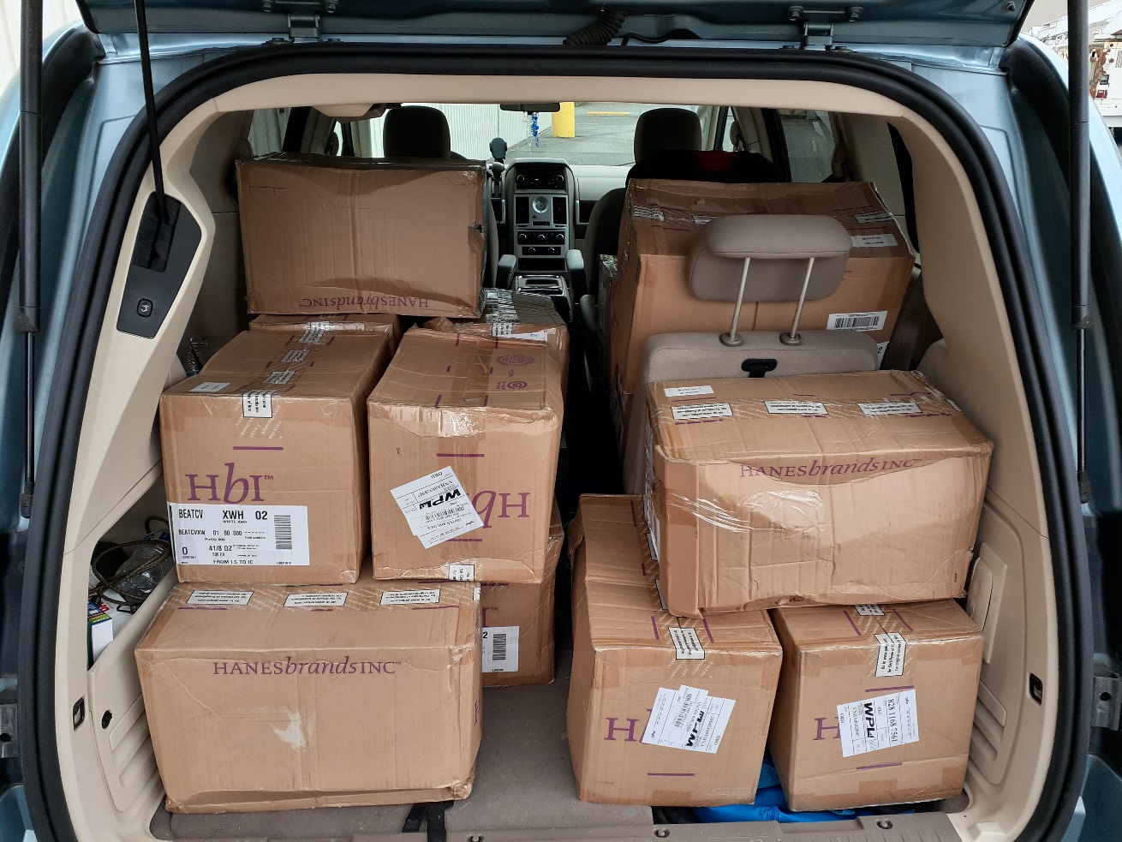
WC EVAC DART ground support person loaded up with the masks from Walla Walla to be broken down and put on planes the following days for further flights out to Jefferson County and Clallam County DART’s.
The “Great Shake Out” is an annual event held on the west coast due to the fact that in time we are due to be hit by a large earthquake causing a tremendous amount of damage that in many causes, especially if the pass highways fail, will cause aviation and in particular general aviation to be a vital means of transportation when the time comes. It is out of this realization of need that the effort called the West Coast General Aviation Response Plane (WCGARP) was born. The belief that General Aviation (GA) has a true gift to be a life saving difference in the response is core to why this was developed. So, for the last 10 years this group of ground support members, HAM operators and pilots has been doing drills on a regular basis to be prepared for when the real thing happens.
This is a very good video that King 5 News did on what this threat that the West Coast faces could do.
https://www.youtube.com/watch?v=kzFYO1EU6rs&app=desktop
As one of the ones helping in this effort it has been truly amazing to see how GA through it’s collaborative efforts with communities, emergency resources at all levels to include even HAM operators has become a light in what would be our darkest hour, a hope that if not for them would be an otherwise hopeless situation for many communities. So, we’ve been drilling every year to develop this resource to its greatest effectiveness possible.
Video of some of the more recent drills;
https://www.youtube.com/watch?v=BBmyiziT63s
https://www.youtube.com/watch?v=jDJFjoXDgWQ
Because of all these years of practice of this group that crosses into many states when a virus of all things, something so small we can’t even see it with our naked eye, caused the pandemic of 2020 we we’re ready and had probably what is a true foreshadowing of what will happen in the aftermath of the earthquake occurred.
Because we were ready for it, when the real need happened, we got the job done.
On October 5, 2020 the 29,000 cloth face masks that FEMA had donated to EVAC/WCGARP effort arrived in Walla Walla. This would be the largest load to date that we’ve flown out.
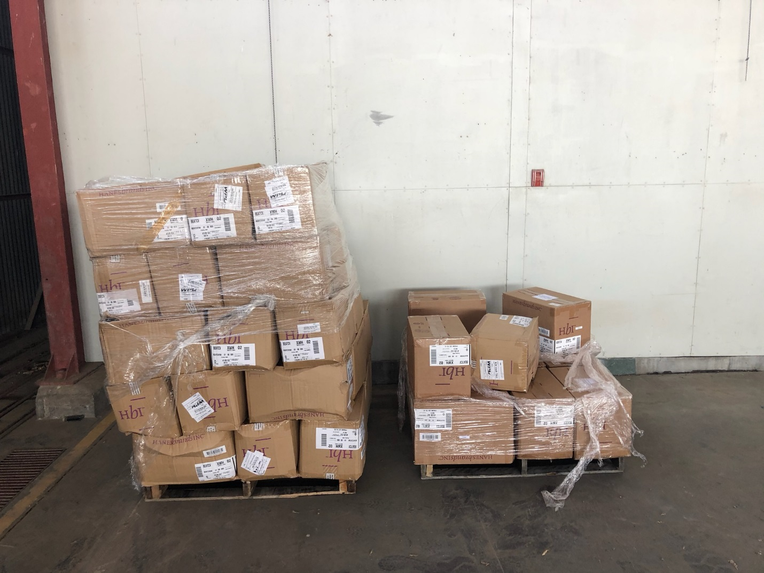
29,00 FEMA donate cloth face masks arriving at Walla Walla
The rest of the below would not have been possible if not for the DART pilots of the WCGARP effort, the Boeing Employee’s Flight Association (BEFA) pilots from Renton Field which they are essentially leading the effort for that site’s DART development, all the ground support personnel involved at many airports, Bellingham Aviation Services at BLI and especially Bill Herrington who leads the Walla Walla DART who has done a tremendous amount of work leading that site’s team in managing all the aircraft uploads as they arrived. Additionally, a huge thank you to the Walla Walla Airport staff and operators that helped with this effort that would not have been possible to accomplish without them.
Once the load arrived the airlift begin. The very next day on October 6th flights to move the supplies out to the designated end point locations began with the first flights leaving from both WC EVAC DART out of BLI and the Renton Field BEFA/DART leaving on that same day. This was a very good example of how quickly GA can ramp up as withing 48 hrs. we had planes up and moving material.
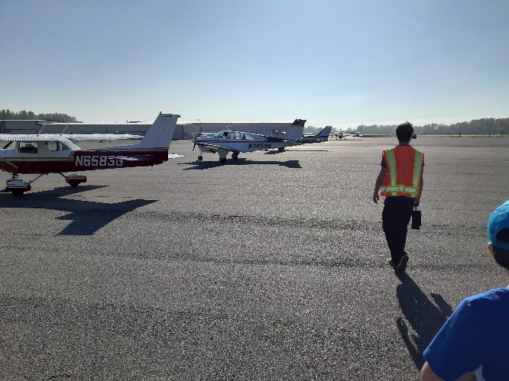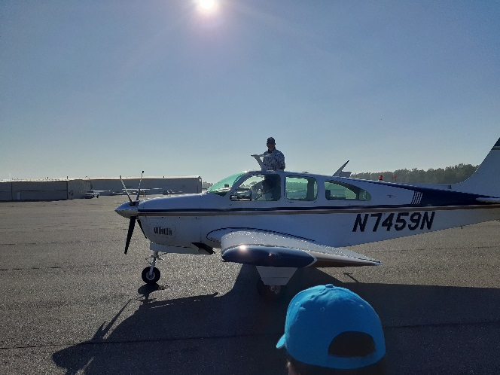
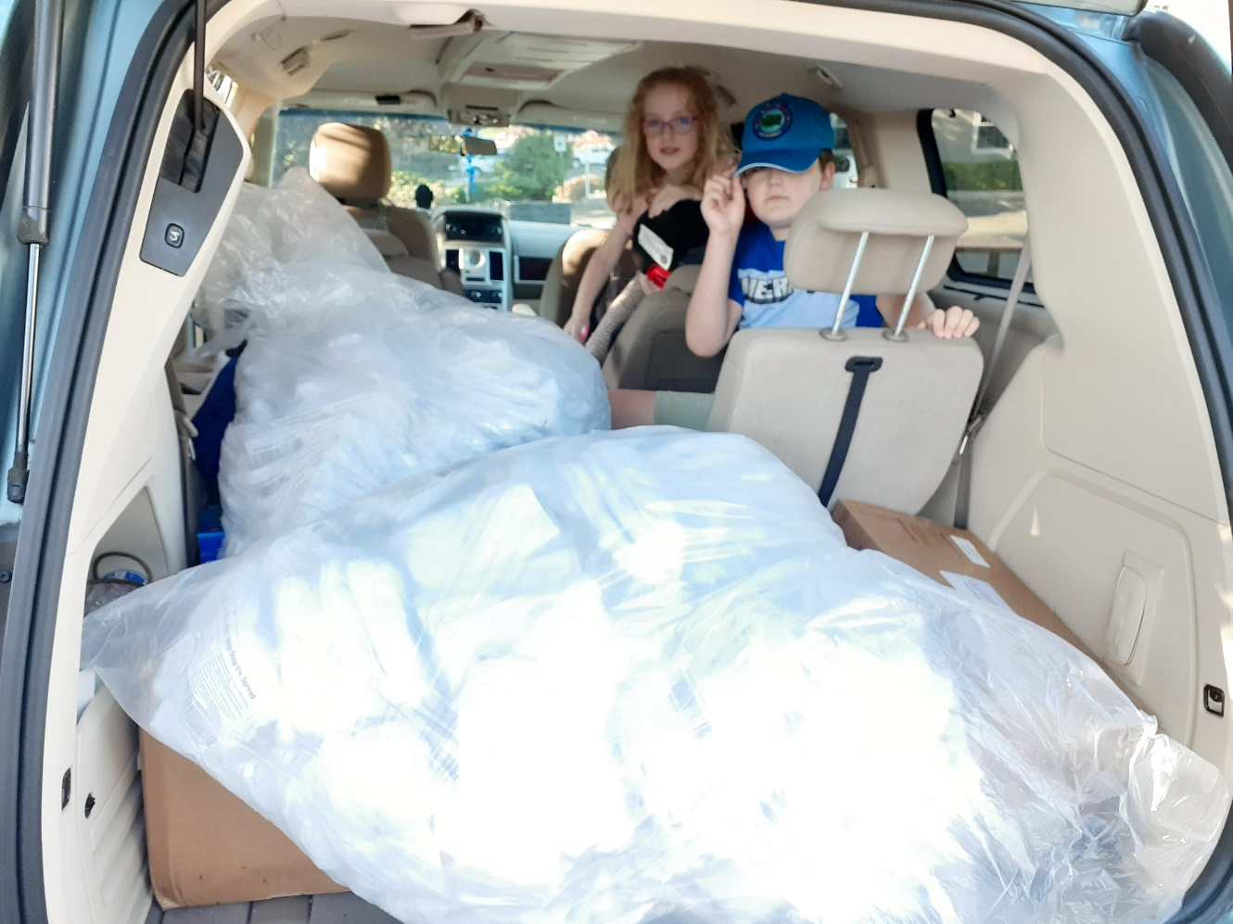
First of the Masks arriving at BLI and being loaded onto the WC EVAC DART ground support person’s van for further delivery out to end points within that sites location and to be loaded onto future aircraft for further transport out.
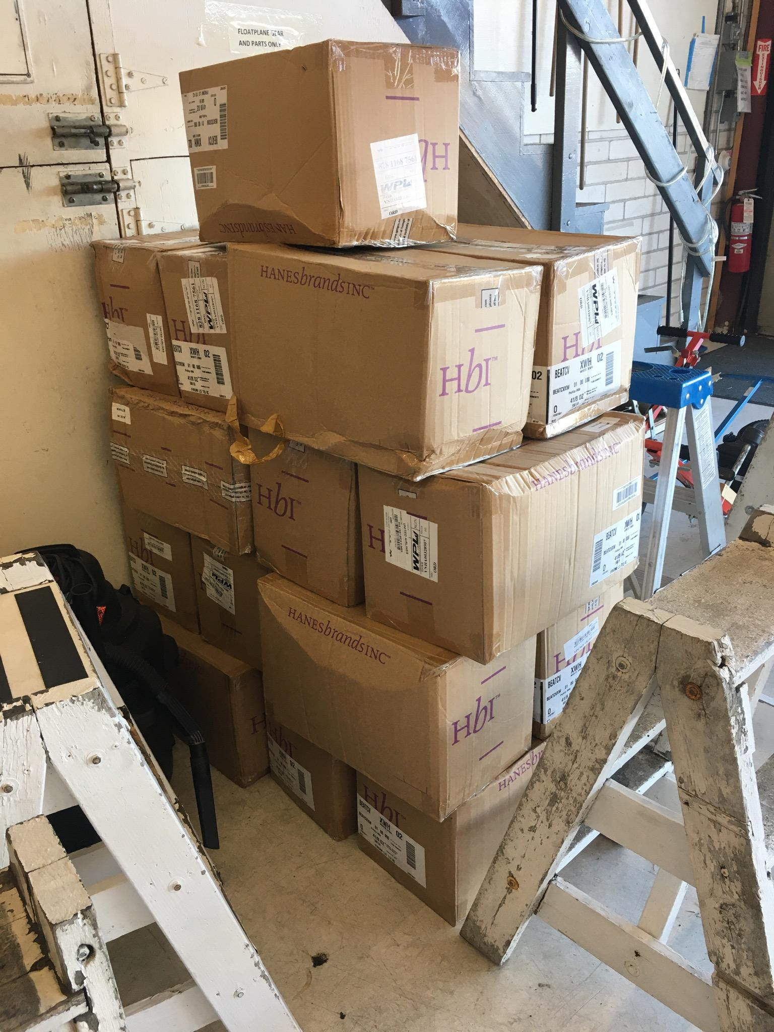
17 boxes of 500 masks each being stored at the hanger at BEFA/Renton Field DART location for further transport out the following days.
By the 2nd day we had moved a good chunk of the supplies out which is a phenomenal accomplishment in my book in terms of response time. This was also important as in doing this airlift we realized Washington State really has 3 separate weather systems that are not always connected to each other in how they affect flight operations but at the same time are. Meaning what is happening on the east side of the range can be totally different then what’s on the west side and even further different from what is occurring on the actual Cascade Pass. But they all impact flight operations and will need to be consider when the “Big One” happens and we just experienced this big time in doing the masks airlift.
I say this because after the first run the weather closed in and while we had to wait until the next week to get the rest of the load (had it been the actual earthquake we could have still flown on the deck up the Columbia River route to get under the weather but that doubles the length so in consideration of pilot expense and length of flight we waited until the weather finally broke) the BEFA/Renton DART was still able to get the rest of their loads that they had gotten over the first day delivered out to the other DART sites in Island County, Grays Harbor County and Mason County.
This was an eye opener in that even though weather really restricted East West operations we were still able to get the loads out that had been able to get airlifted the 2nd day. It also brought to light how important it’s going to be to have prepared teams ready to go after the earthquake because in the real thing you don’t know how long a window you’ll have before weather impacts flight operations so when you have the window it will be crucial to make the runs while you can to get as much over before the weather shifts.
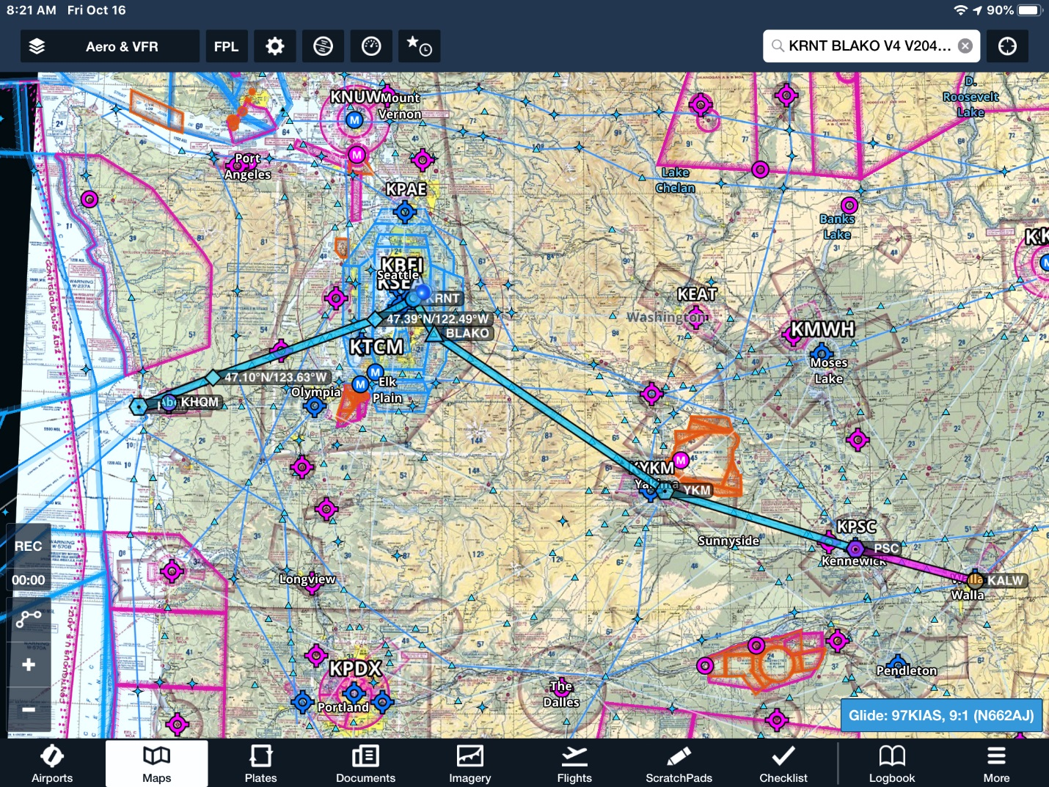
The above is just one of the runs the BEFA Renton Field DART did. We showed this one as it was over all one of the longest runs of the effort.
This was an amazing demonstration of capability as in this effort both the BEFA Renton Field DART and the WC EVAC DART served as forward logistical bases for what was ground shipped to Walla Walla. By doing this it gave us the ability to get a large portion over to then distribute out further. By at least getting it over the hump (Cascade Pass) first it allowed us to be less constricted by weather in operations. This makes a big difference in the response effort.
Then the following week we did the last load, and this was also of note worthy in that it was on the same day as the “Great Shake Out”, didn’t plan it that way as it was dictated by weather. So, for the first time in doing these drills we flew a live load in a real response effort on the same day of one of the bigger West Coast earthquake preparedness efforts. That in my book is amazing.
Once more, even during this effort, the ability to have redundancy proved crucial. The plan was for both BEFA Renton Renton Field DART and WC EVAC DART’s to both launch planes to get the last of the load now that we had the break in the weather. WC EVAC dart was able to launch but after they had launched, I got word that Renton Field DART had a mechanical, so it got scrubbed, but it wasn’t a showstopper. We had time to notify Walla Walla DART that Renton got scrubbed and see if they could load Renton’s load along with WC EVAC DART’s load onto the EVAC DART plane once they arrived. That proved fortuitous as he was able to do so, and it was a good thing as the weather really turned to crap the very next day. So, a huge thank you to Paul Zosel for being very flexible and coming through in a pinch.
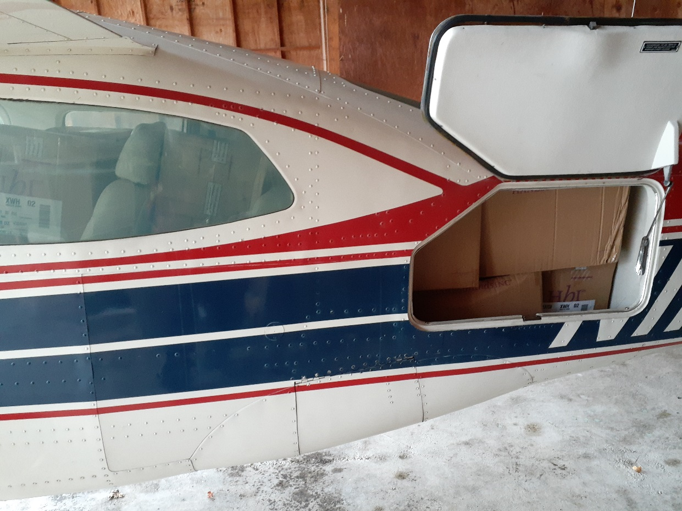
A full plane coming back from Walla Walla with both WC EVAC DART and Renton Field BEFA/DART loads.

Then the following days it was picked up and flown on to their final destinations of Clallam County and Jefferson County DART’s along with Renton Field BEFA/DART picking up their loads.

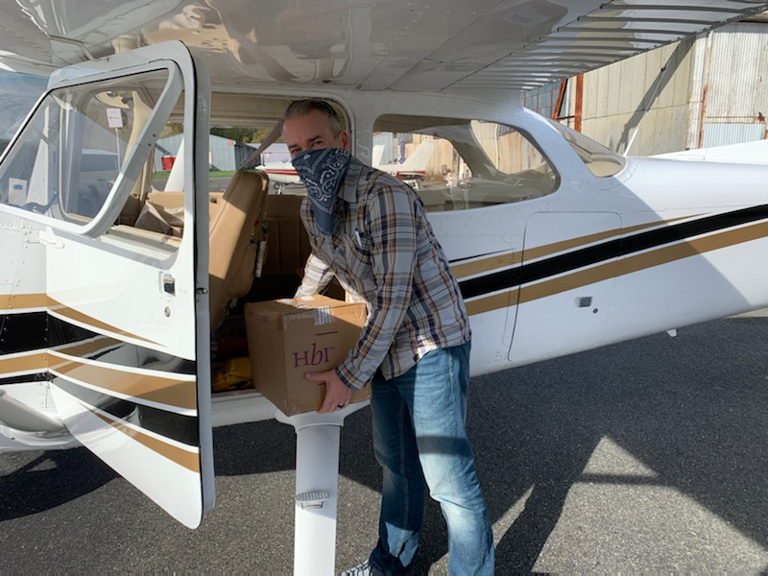

Jefferson County DART receiving their load.
But Washington state wasn’t the only destination. We also sent a load from Walla Walla to Idaho DART group.
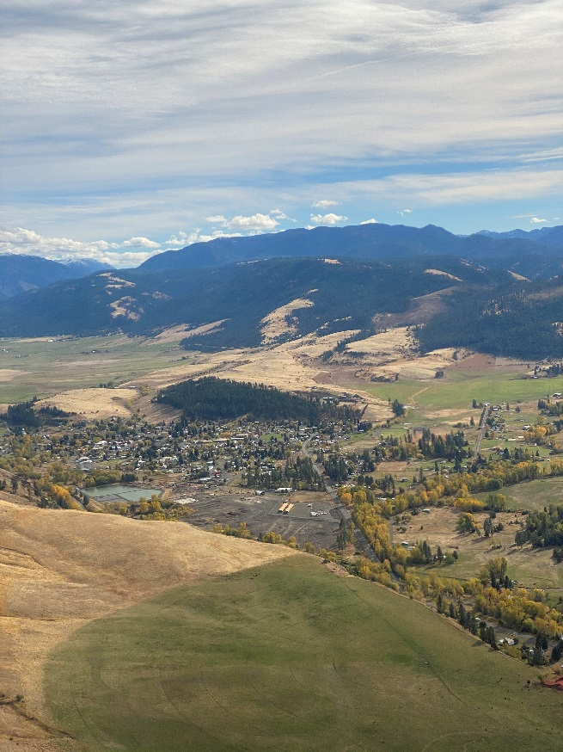

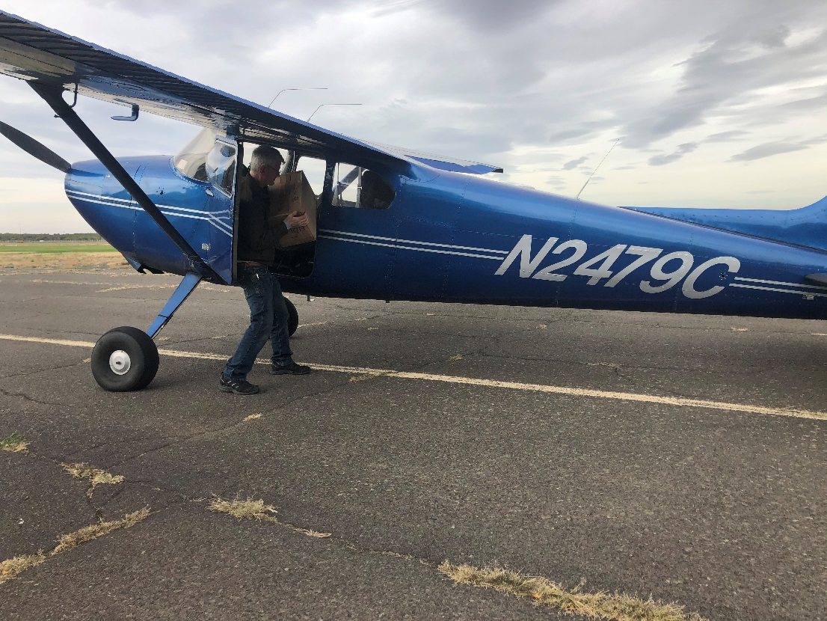
Idaho pilot delivering their load.

Additionally, a load went to the DART location in Clark County.
So, after years of labor and years of refinement when the time came the WCGARP was ready and boy did it prove that it can make a positive impact when the time comes.
For everyone who has helped and continues to help over so many years of work and labor a thank you that words can never adequately express enough. For what we’ve created together will be a miracle for too many to count when it is needed most.

Sincerely,
Sky Terry
Sky Terry
NW Regional Emergency Services Director
EVAC Emergency Volunteer Air Corps
http://www.evac.org/
http://www.evac.org/northwest.htm
CPR Instructor, LPN
425-737-3923
